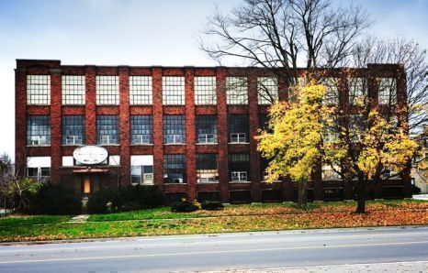

Oxford Historical Society

Looking for the assistance of women who were employed at
E.E. Paquette or Harvey Woods

It does not matter what years or for how long you were employed
A story will be compiled through your collective experiences.

Please come to The Salvation Army on 769 Juliana Drive
Wednesday June 13 at 10:00 a.m.

If you are able to assist us please call
Elaine Becker at 519-537-1086

